Sprint 12

Business and Functional Requirements Document (Sprint 12)
  - November , 2025

Contents
Requirement Title 1: Accessibility Testing 2

Document Control & Revision History
Document.
Title of Document | Sprint 12 - Business and Functional Requirements Document
Purpose | The Business and Functional Requirements Document consists of the Sprint 6.1 functional areas, user roles & permissions, and detailed business requirements.
Location | https://fairfaxcounty.sharepoint.com/:w:/r/sites/Team-FFX-CiviCare/Shared%20Documents/Phase%202/BRDs/Sprint%207/Sprint%207%20BRD%20v2.0%20.docx?d=wc4ad91d8557a416593e24671e9e13f5c&csf=1&web=1&e=pZTdUg
Owner/ Author
Name | Divya Anbuselvan
Title | Sr. Business System Analyst (MTX)
Department | PMO
Email | Divya.anbuselvan@mtxb2b.com
Phone | 832-339-4599
Reviewer(s)/ Approvers
Business Office | Reviewer Name | Signature/ Initials | Date
FFX |  |  | mm/dd/yy

Change Details
Version | Change Highlights | Author | Date
1.0 | Initial Draft | Divya Anbuselvan | Nov 25, 2025

Requirement Title 1: Accessibility Testing
Overview:
This report summarizes the accessibility testing performed on the Fairfax Assistance Portal to assess its compliance with WCAG guidelines and evaluate the impact on end users, especially those relying on keyboard navigation and assistive technologies. The assessment covered all key customer-facing pages, and documents both the accessibility issues detected and the proposed remediation approach.
Accessibility evaluation was conducted using the Siteimprove Accessibility Checker as the primary testing tool, supplemented by a manual review of page structure, headings, links, ARIA usage, and interactive elements. The scan revealed multiple accessibility issues related to color contrast, ARIA landmarks, visible label mismatches, link visibility, control sizing, and text presentation, which may affect both usability and readability across devices.
To validate specific issues such as contrast ratios, heading hierarchy, and link visibility, supporting tools like the WAVE Web Accessibility Evaluation Tool and WebAIM Contrast Checker were referenced as part of secondary validation efforts. These tools helped verify findings flagged by Siteimprove and ensure alignment with accessibility best practices.
Overall, this report provides a consolidated summary of issues and outlines recommended fixes that can be implemented through Portal Management and CSS overrides to improve accessibility and user experience across the portal.
The key customer-facing web pages that were covered as part of accessibility testing are as follows:

- Common Pages - Home, HSRG, HSRG > Reports, FAQs, Help
- Profile: Community Member - Assistance Requests > My Assistance Requests, Assistance Requests > My Withdrawn Assistance Requests, Assistances, Assistances > Assistance Details, Profile
- Profile: CBO - Accounts, Accounts > Account Details, Accounts > Referrals, Accounts > Report, Profile

Below are the errors:
- Interactive elements do not meet enhanced size (2.5.5):
Buttons or clickable areas are too small, which makes it hard for keyboard and touch users to interact with them.
Proposed fix: Increase minimum touch target size (44×44px) using CSS and ensure padding/margins are sufficient.
- Visible label and accessible name do not match (2.5.3):
The text shown visually is different from what assistive technologies read, leading to confusion for screen reader users.
Proposed fix: Align aria-label/aria-labelledby with visible text OR use aria-hidden where required.
- Text not included in an ARIA landmark:
Important content is not enclosed within ARIA landmark regions (like <main>, <nav>, <header>), reducing page structure clarity for screen readers.
Proposed fix: Wrap major sections in <main>, <nav>, <header>, <footer> or assign correct role attributes.
- Links are not clearly identifiable (1.4.1 - Use of Color):
Links rely only on color to show they are clickable but need an additional cue like underline or hover effect.
Proposed fix: Add underline or hover states using CSS (text-decoration) to visually distinguish links.
- Color contrast does not meet enhanced requirements (1.4.6):
Text and background colors do not have enough contrast, making content hard to read, especially for users with low vision.
Proposed fix: Adjust text/background colors to meet WCAG contrast ratio of at least 4.5:1 (AA) or 7:1 (AAA)
- Line height is below minimum value (1.4.8 - Visual Presentation):
The spacing between lines is too tight, reducing readability and failing WCAG guidelines.
Proposed fix: Increase line-height to 1.5 or higher for readability in CSS.
- Font size is fixed (Violates 1.4.8):
Font cannot resize properly, which makes it difficult for users who rely on zoom or customized text sizes.
Proposed fix: Use rem/em instead of px and avoid hard-coded font sizes.
- Content missing after heading:
A heading is present, but no supporting content follows it, which harms page structure and confuses screen reader users.
Proposed fix: Add meaningful content below the heading or remove unnecessary headings.
- ARIA attribute unsupported or prohibited:
Some elements have invalid or incorrectly used ARIA attributes, which may cause screen readers to misinterpret content or ignore accessibility features.
Proposed fix: Remove unsupported ARIA attributes or use only valid combinations of role, aria-*, and semantic HTML elements
- Interactive elements do not meet minimum size nor spacing:
Some buttons or links are either too small or too close together, making it easy for users to activate the wrong control.
Proposed fix: Ensure each interactive element has at least a 24×24 px target or enough spacing around it (e.g., 8-10 px), using padding/margins so that the overall tappable area is comfortably large and clearly separated from neighboring controls.

Common Pages:

- Target Page: Home
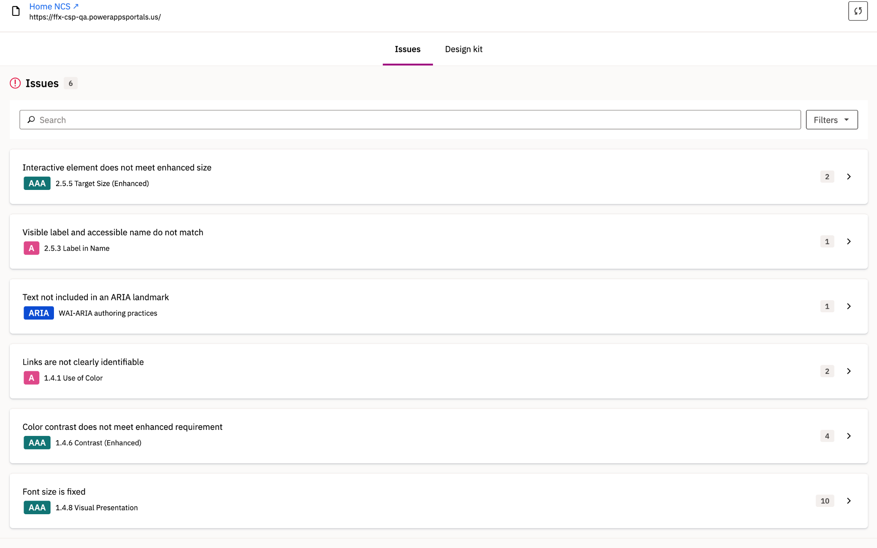

- Target Page: HSRG
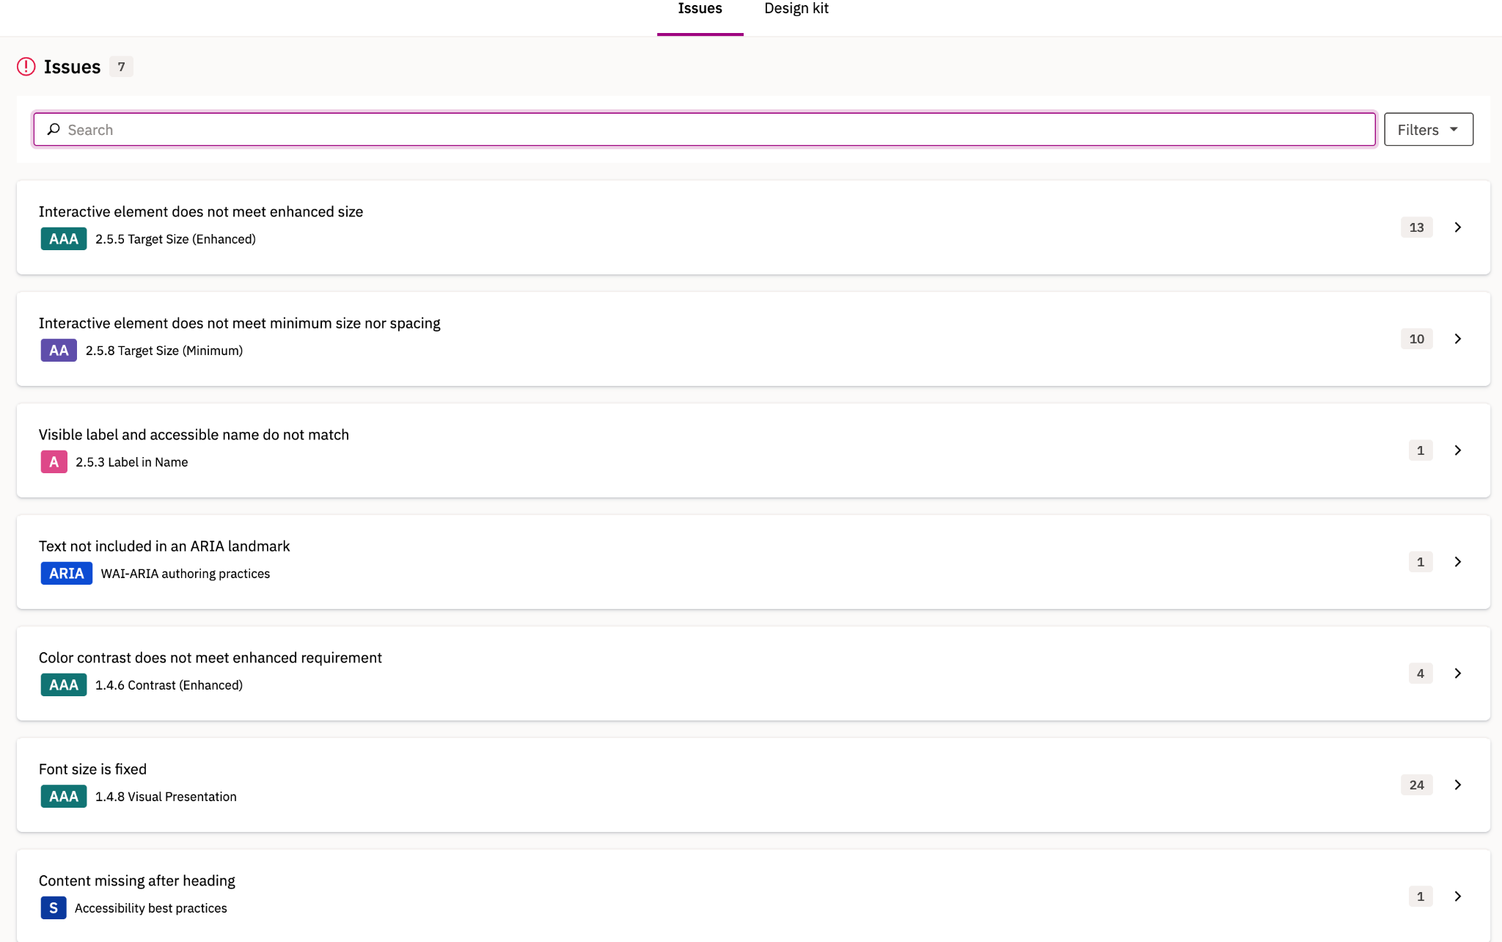

- Target Page: HSRG > Reports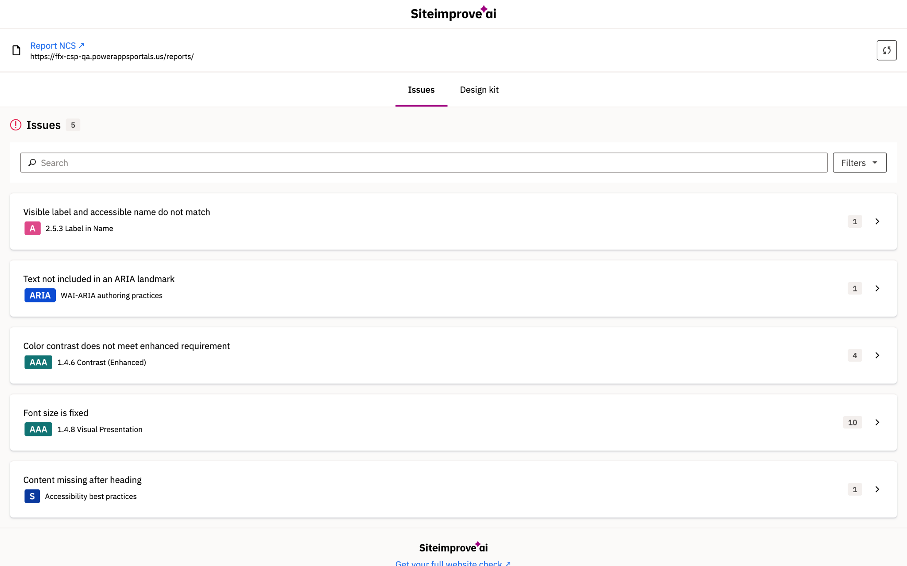

- Target Page: FAQs
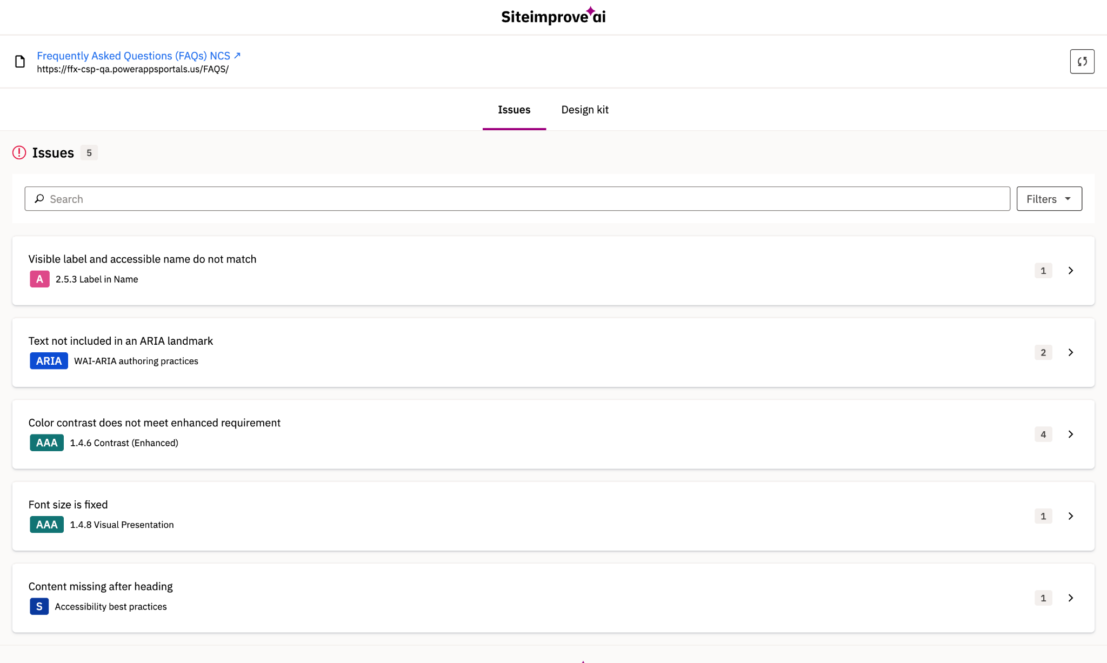

- Target Page: Help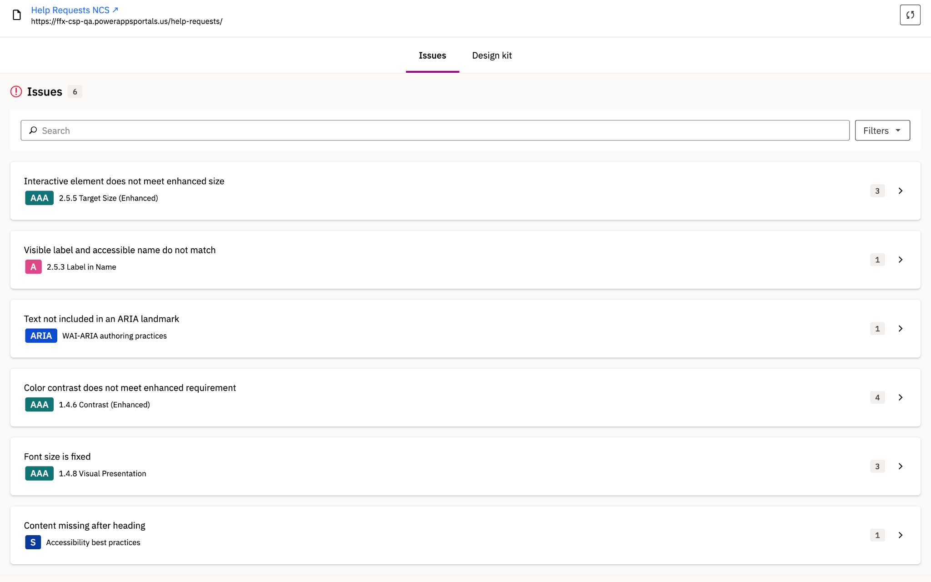

Profile - Community Member

- Target Page: Assistance Requests > My Assistance Requests
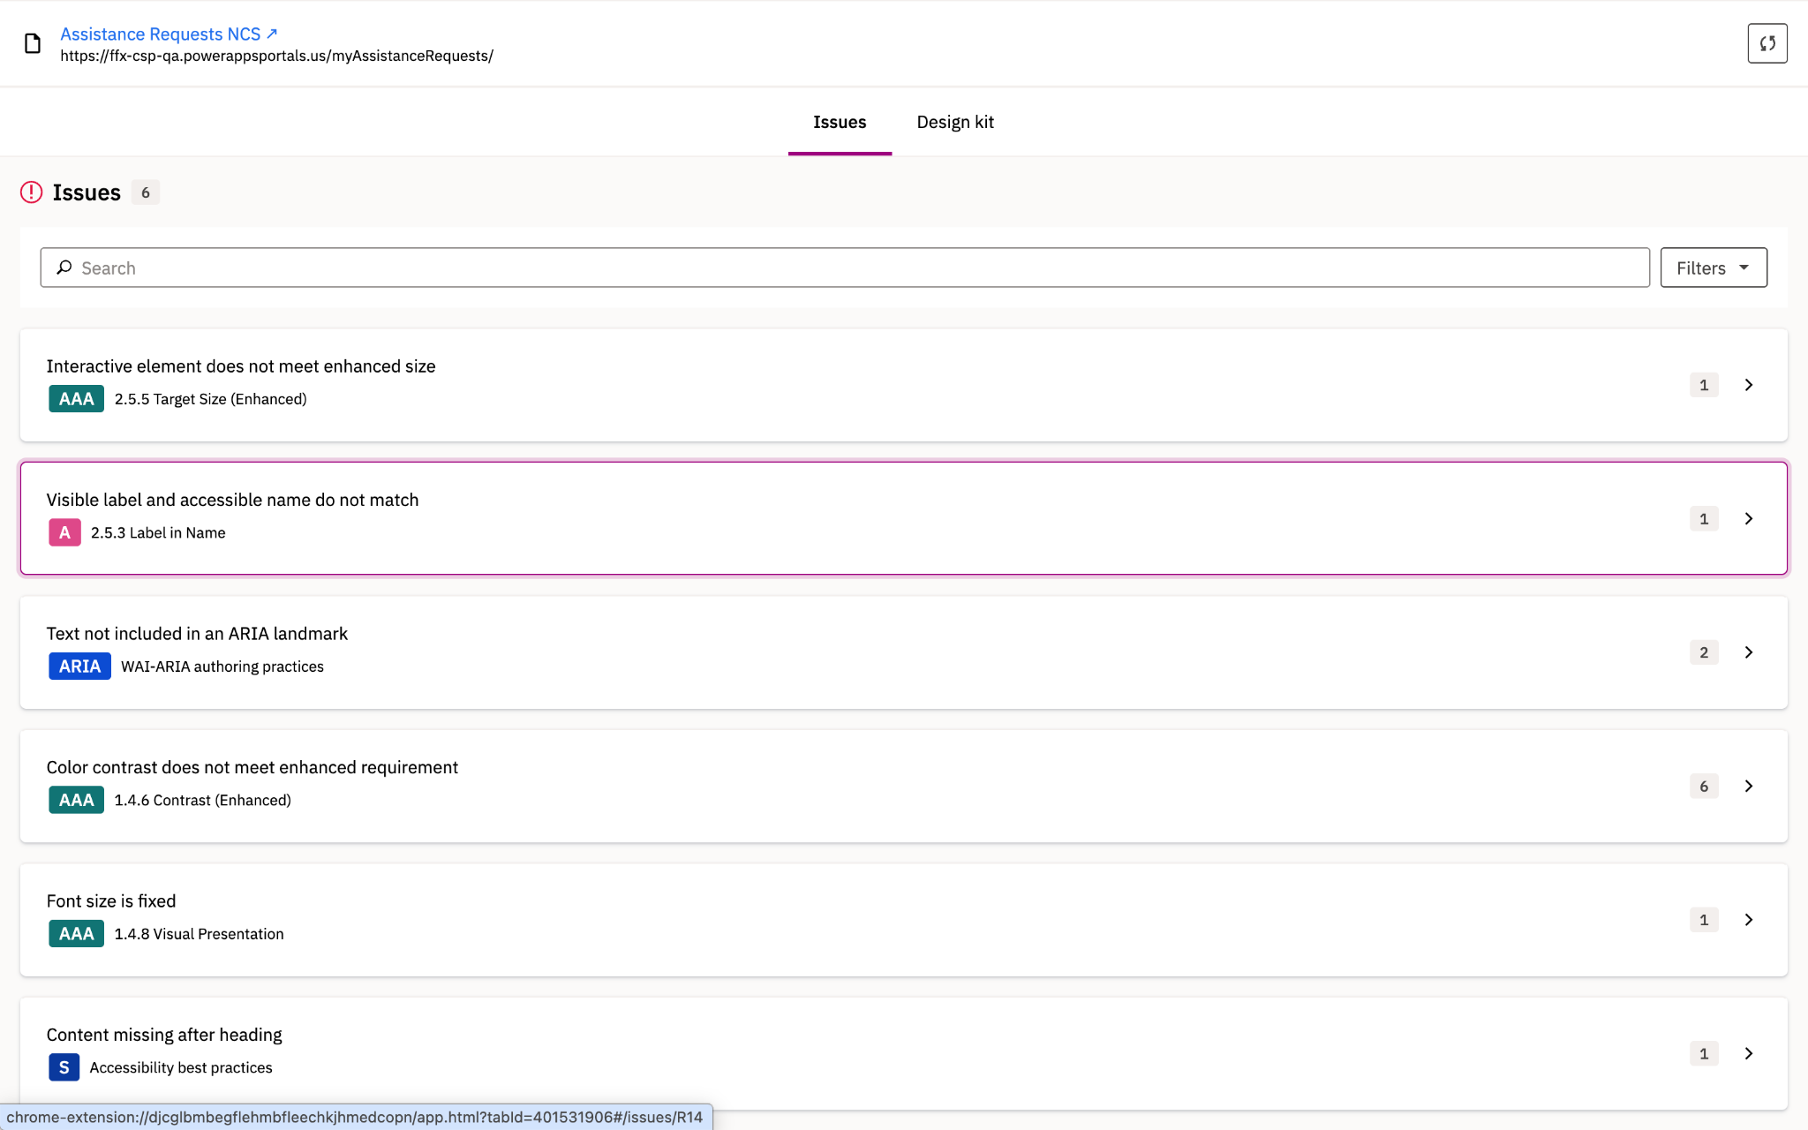

- Target Page - Assistance Requests > My Withdrawn Assistance Requests
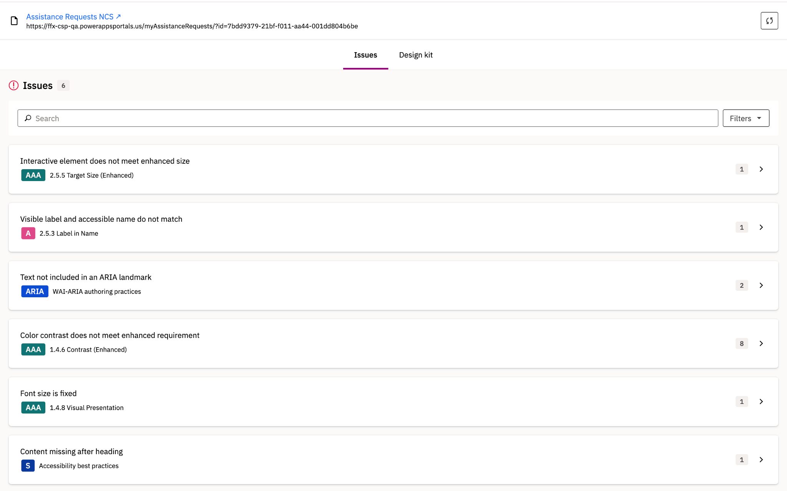

- Target Page - Assistances
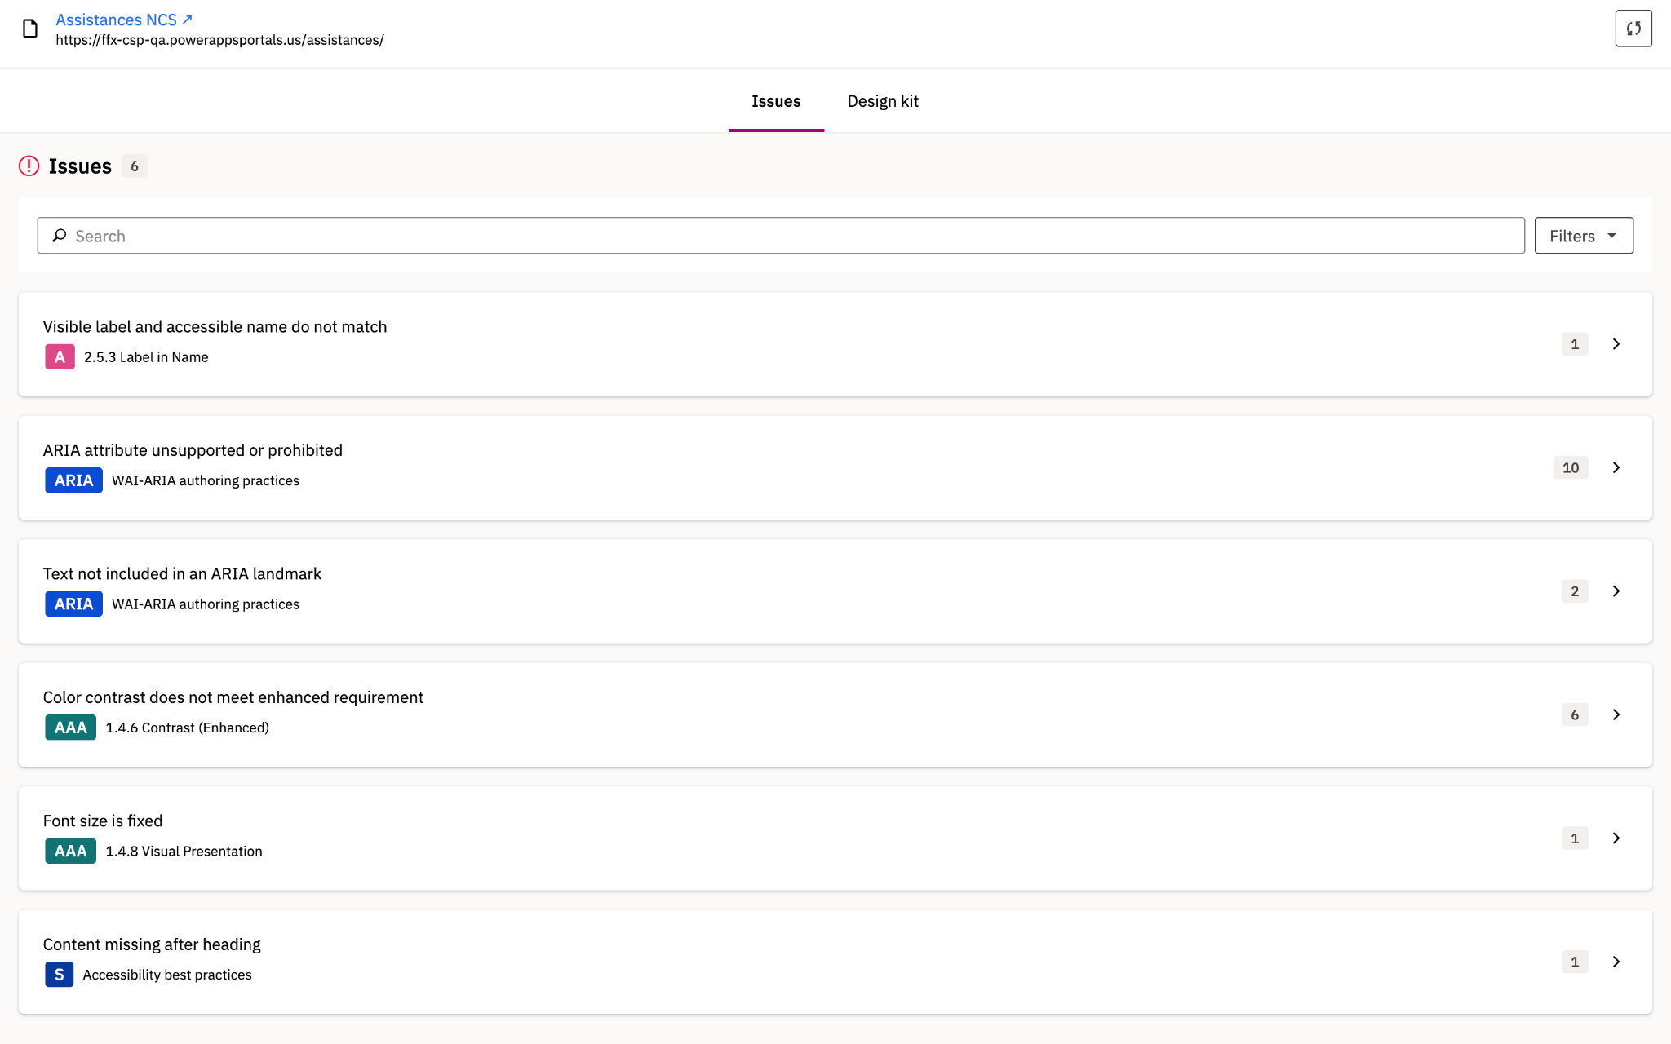

- Target Page: Assistances > Assistance Details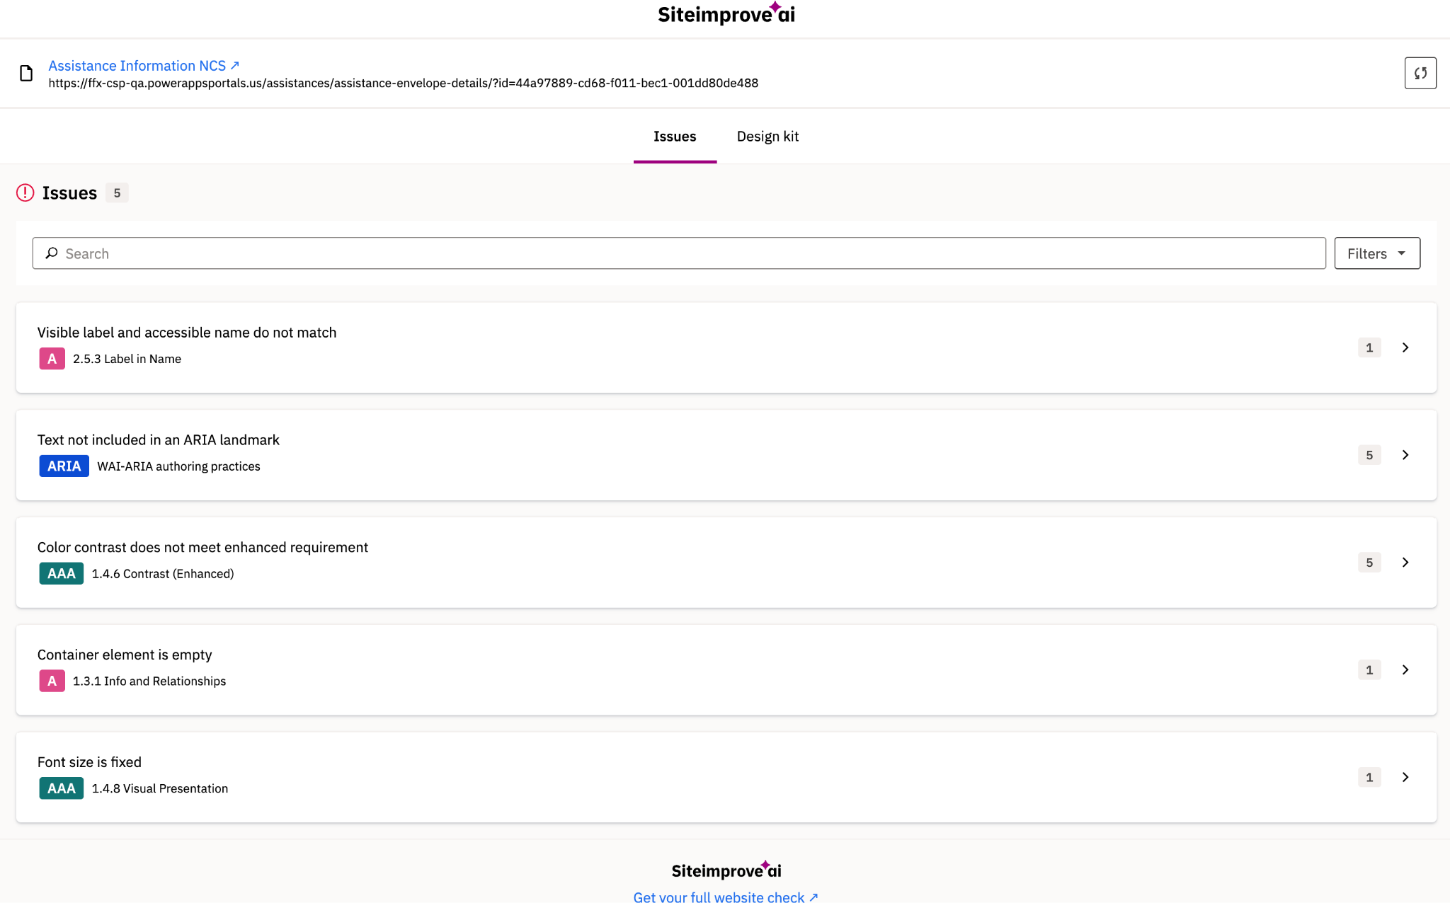
- Target Page: Profile
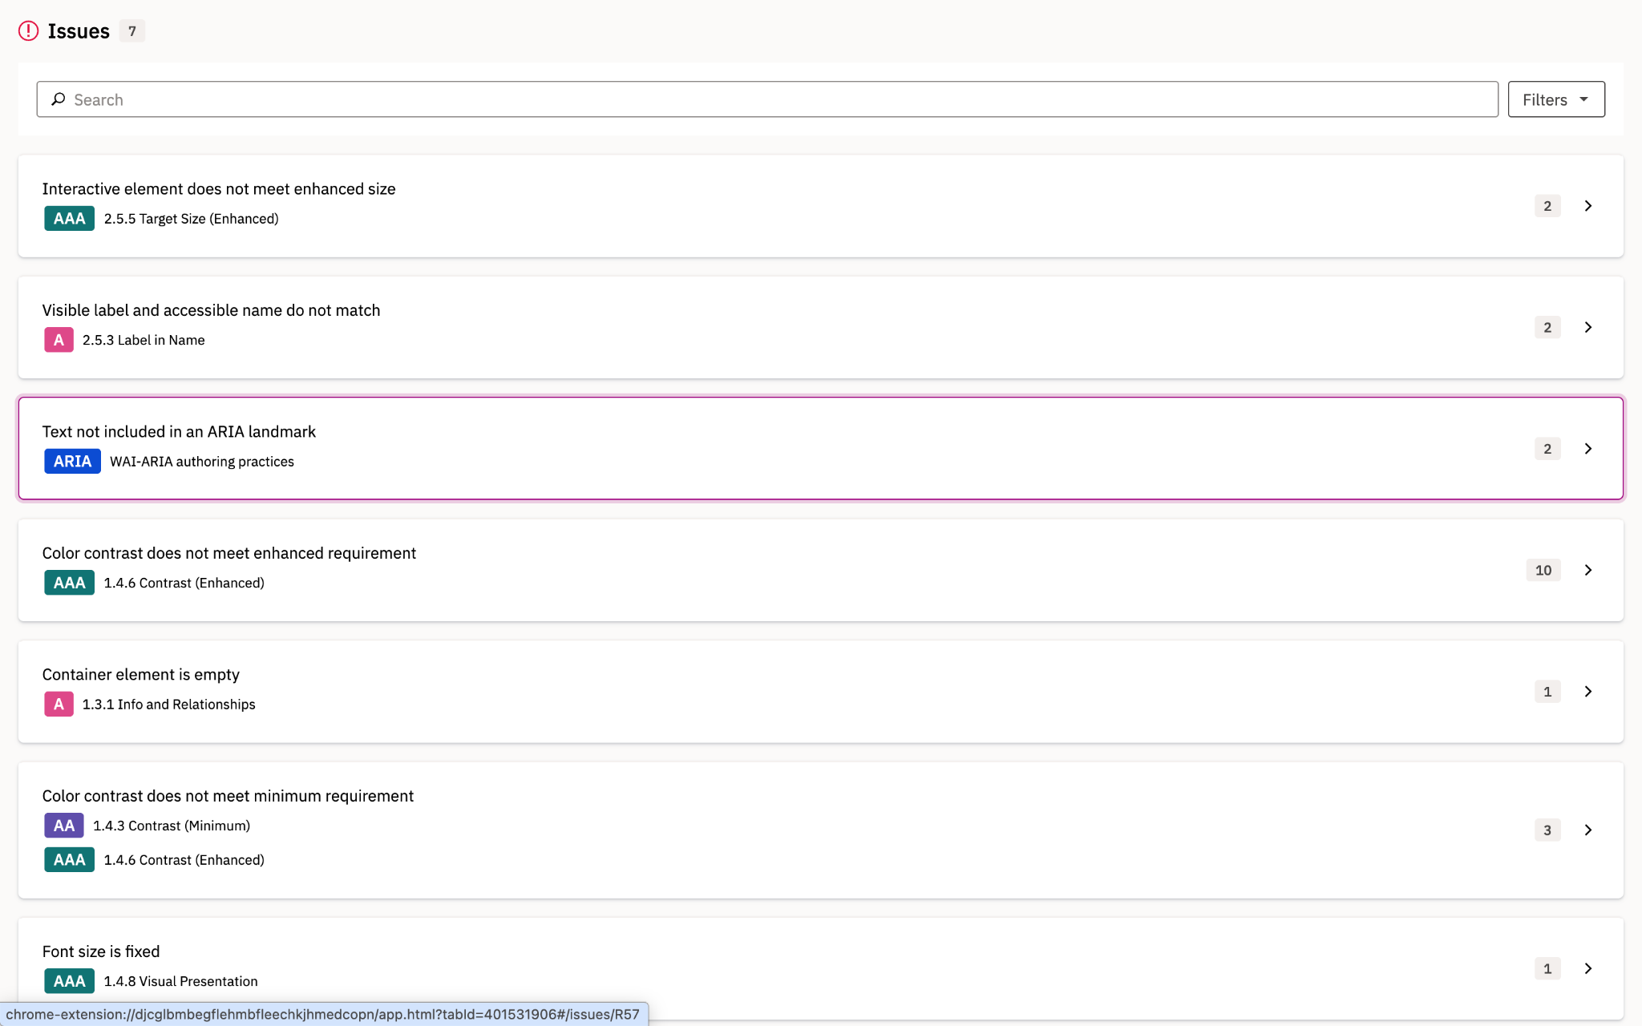

Profile – CBO

- Target Page: Accounts 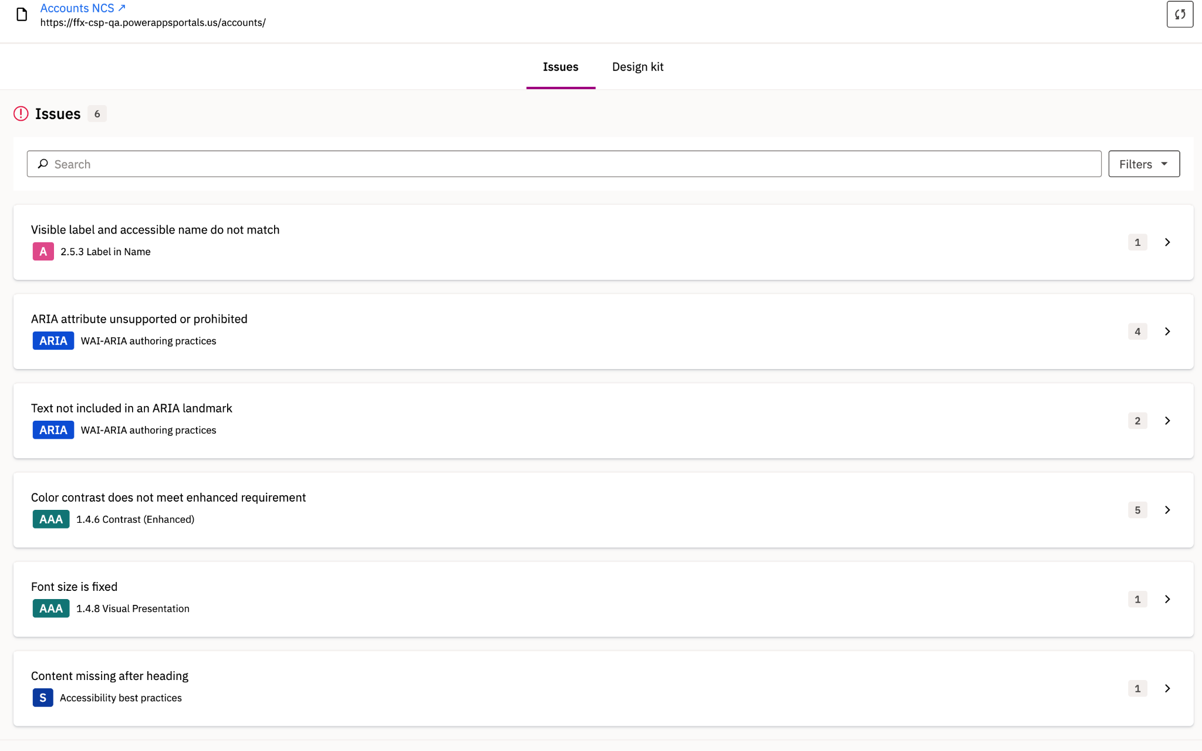

- Target Page: Accounts > Account Details
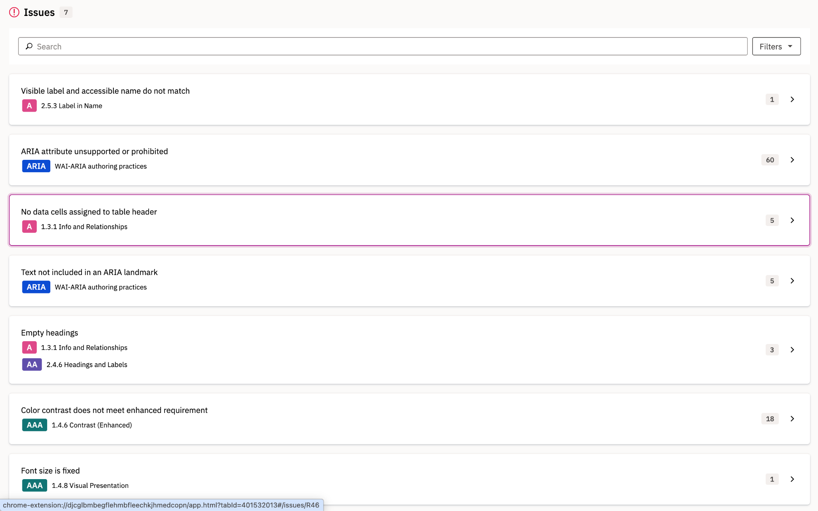
- Target Page: Accounts > Referrals
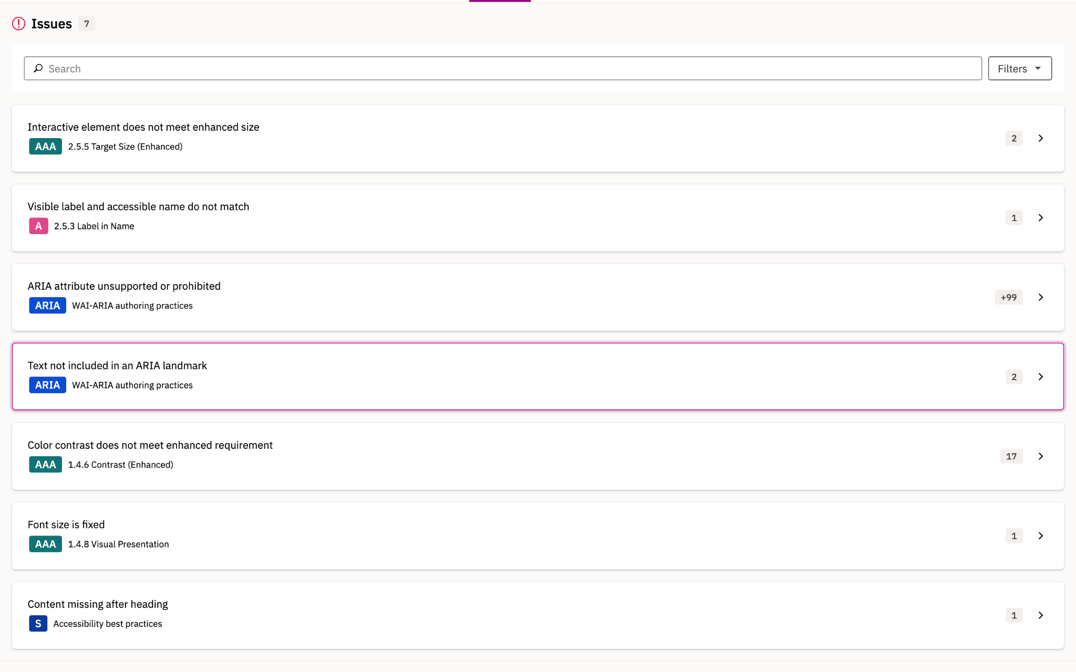

- Target Page: Accounts > Report
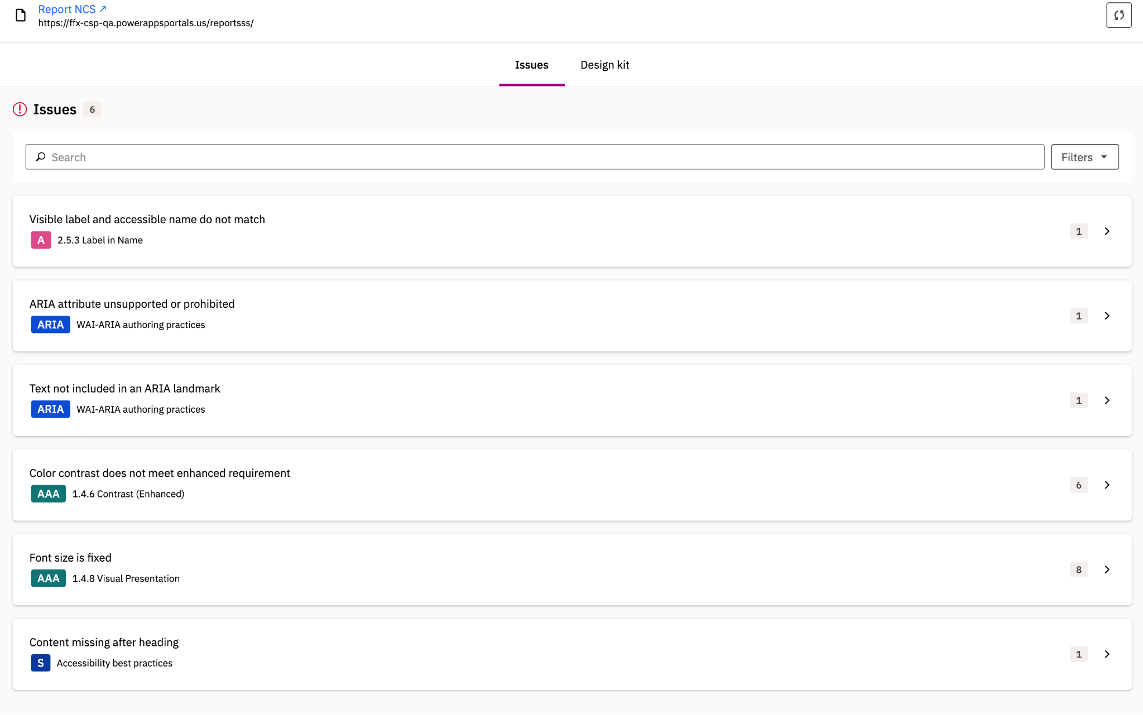

- Target Page: Profile

